

**E-Commerce**

COVID-19

Prof. JAYAKUMAR S



**TEAM**

Mohit Gupta(19BIT0055) Kumar Abhijeet(19BIT0051) Dhruvil Dave(19BIT0065) Shreyash vardhan(19BIT0001)

**Content**

**01**

**TITLE**



1. **INTRODUCTION**
2. **ARCHITECTURE**
3. **FLOW CHART**
4. **SYSTEM DETAILS**



# INTRODUCTION

* Our team, is trying to create an e-commerce website focused on supplying safety products to fight COVID-19 .
* Our website will have various safety products like masks, sanitizers (liquid or gel or spray) , PPE kits and more, that shall be sold via single website .
* We aim to reach to more & more customers with economical offerings to fight COVID 19 .
* Our website is aligned to “principal of social distancing” yet helping every customer with best offering in terms of quality and prices.
* We feel as IT students, we can help the community with more options to choose from for the safety products which can be procured from single mouse click.



## What is an E-Commerce website

**Ecommerce**, also known as ‘Electronic commerce’ or ‘Internet commerce’

It means:

1.where business is enacted using website / digital payments . 2.buying & selling of goods or services using internet, and the transfer of money and data to execute these transactions.

E-Commerce started way back in 1960s when organizations began to use Electronic Data Interchange (EDI) to transfer documents of their business back and forth.

[**FACT :** “In 2020, eCommerce sales are expected to account for 15.5](https://www.oberlo.in/statistics/ecommerce-share-of-retail-sales) [percent of retail sales worldwide.” (Source : https://cyberchimps.com/e- commerce-websites/)](https://cyberchimps.com/e-commerce-websites/)

**ARCHITECHTURE DIAGRAM**

WEB BROWSER

Request for

dynamic W6 page

8. DyFI8lT\ie Web

page HTML file

dynamic Web page

6, ftctricvcd data

7. Dynamic Web page HTML lilc

WEB SERVER

(Running program to

4. Data query| Retrieved data

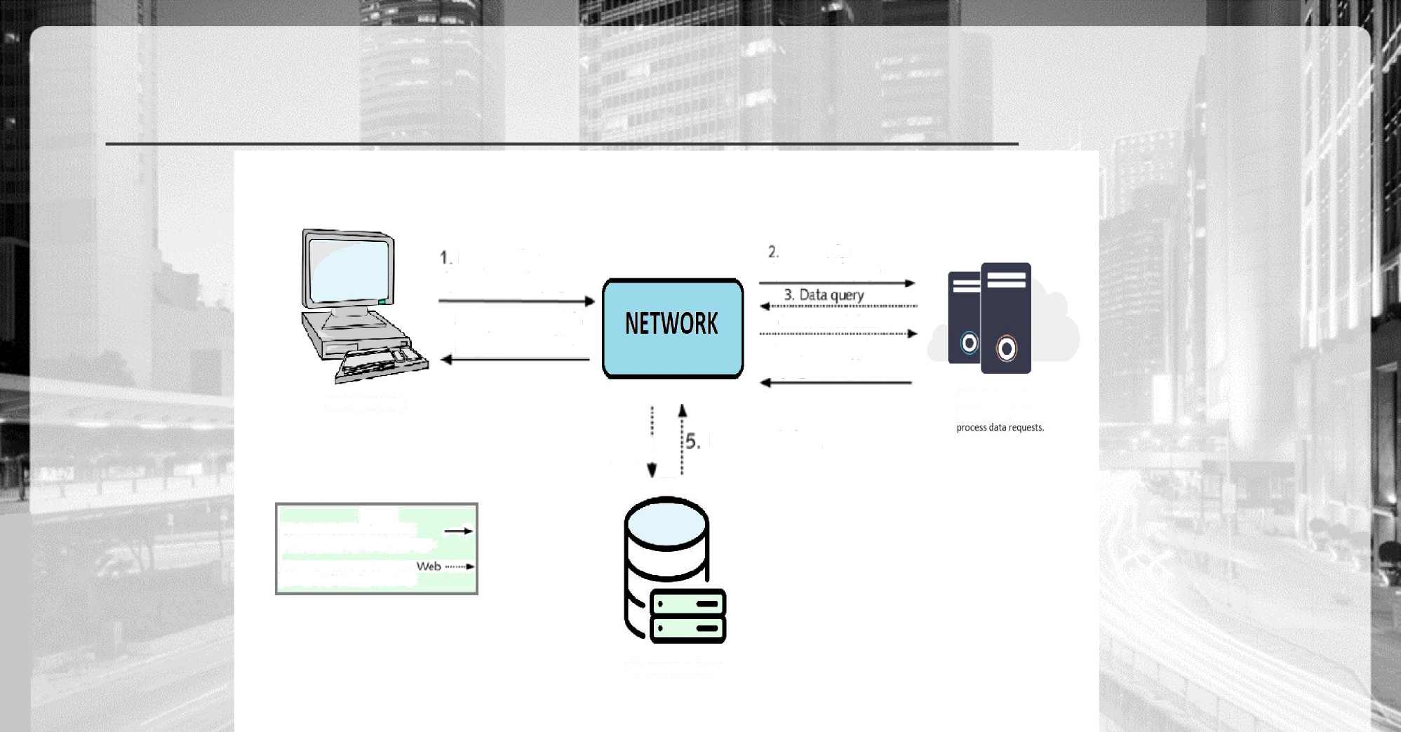

Legeod Communications between Web browser and Web sender

Communications between server and database server

DATABASCSERVER

**FLOW CHART**

Home

About products

Login

Sign up

Free check up

Med kit Sanitizer N95 Mask

Products

Purchase

Home(Re-

login)

Purchase

Med Kit

Purchase

Sanitizer

Purchase

N95 Mask

Payment



Payment

Payment



# SYSTEM DETAILS

**Programming Languages Html 5, CSS,JavaScript,PHP**

**Database used MySQL**

**Framework Bootstrap, Materialize , LARAVEL**

**Other Tools**



**JQuery, VS code,**

**GitHub,XAMPP,APACHE**



**THANK YOU**